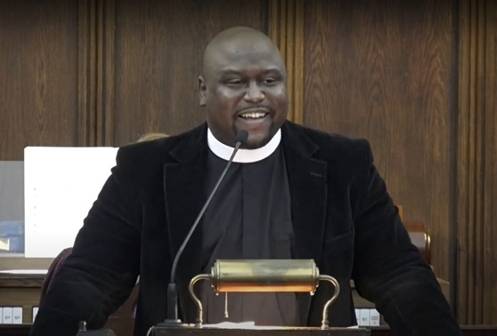

The Reverend Co’Relous C. Bryant is the Associate for Mission at The St. James’ Church in New York City. He obtained the Bachelor of Arts degree from New York University (NYU) where he focused on political science and theater. He obtained the Master of Divinity degree from Emory University’s Candler School of Theology in Atlanta, GA, specializing in homiletics and pastoral care. Co’Relous has worked as a community organizer, nonprofit manager at United Way, Big Brothers Big Sisters, and the Jacksonville Public Education Fund. He is especially proud of his work at Rethreaded, a social enterprise that combats sex trafficking. He was the 2022 Vestal Scholar, the highest award from the Cooperative Baptist Fellowship. Co’Relous is the 2007 National Oratorical Champion for the American Legion. Co’Relous has been heard on National Public Radio (NPR), Metro Baptist Church NYC, Madison Avenue Baptist Church NYC and as the keynote preacher at the Baptist Fellowship of the Northeast in 2022.

